## Hybrid connection:

<https://www.youtube.com/watch?v=y_zAJZC_8Yk>

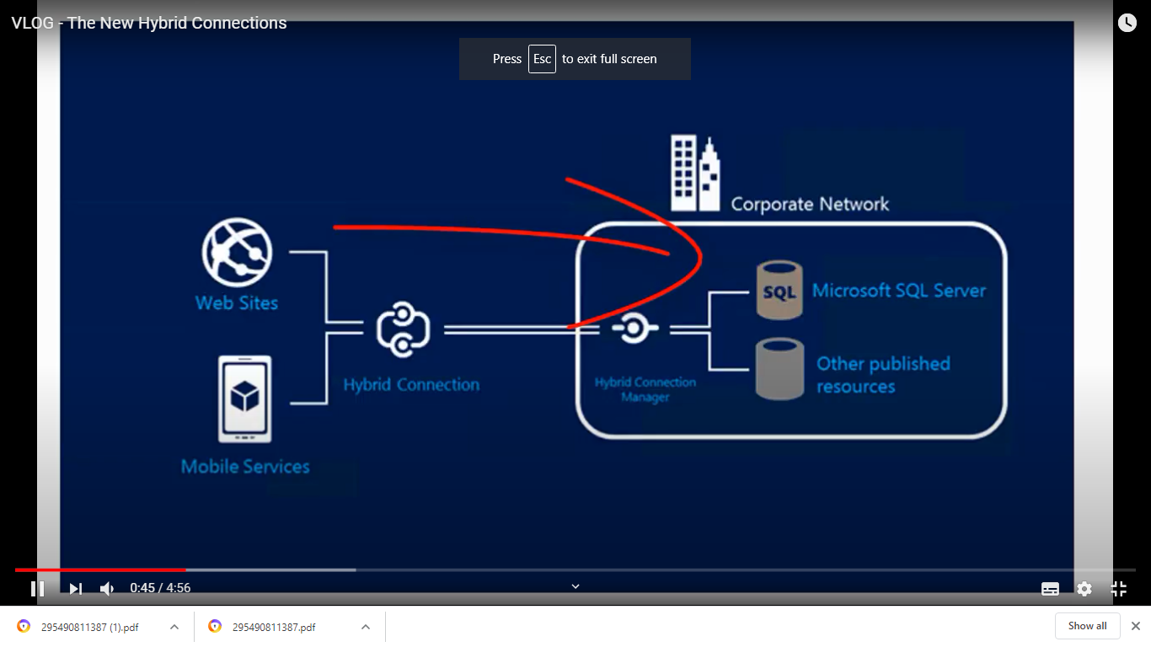

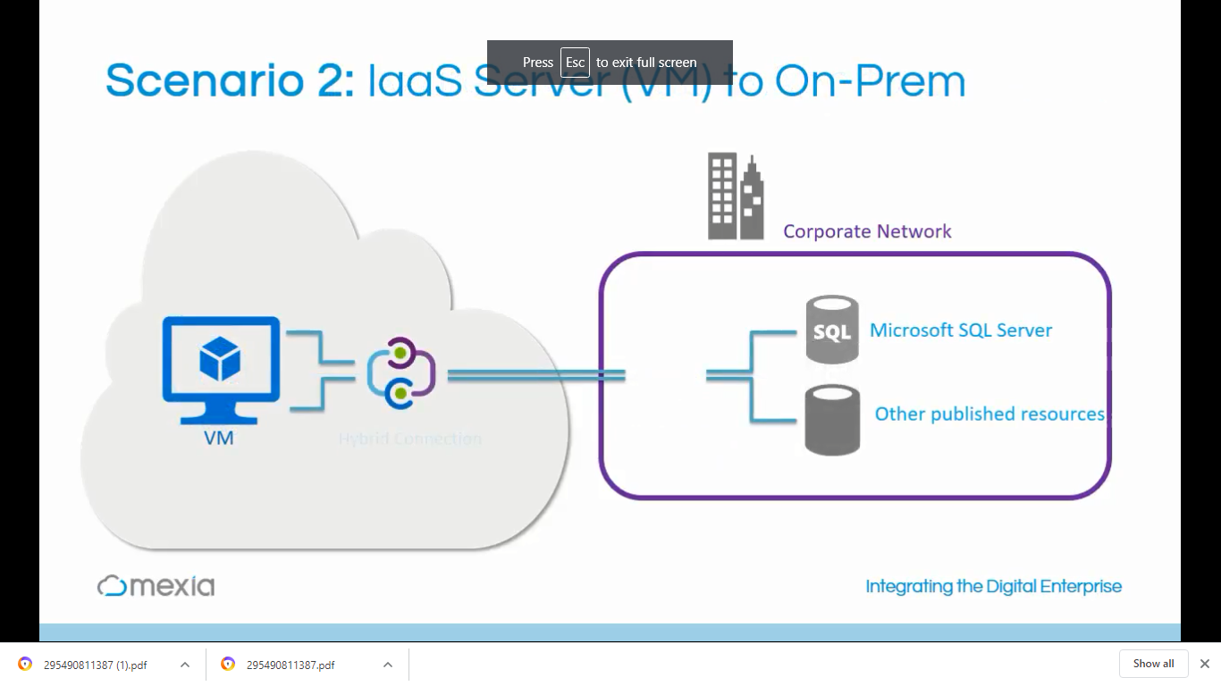

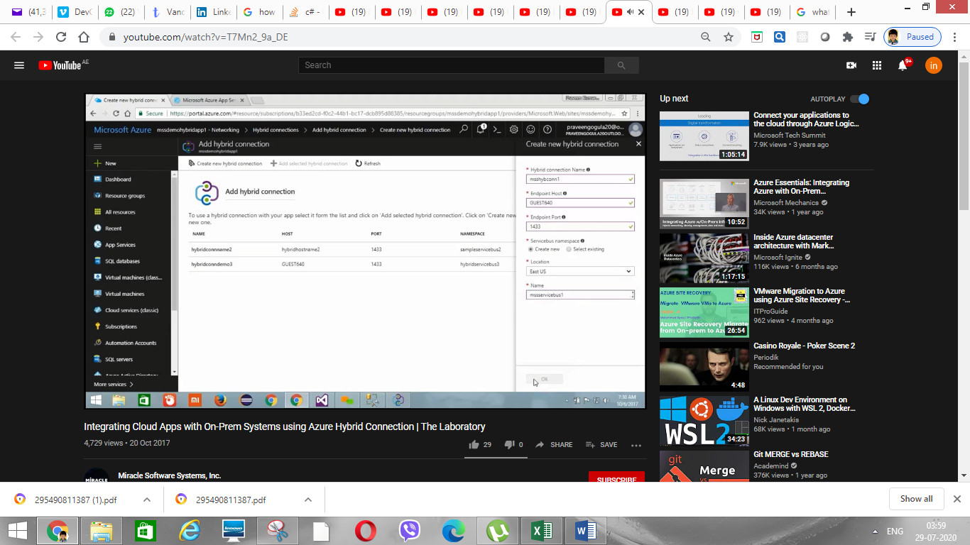

**Hybrid connection manager** to connect on premises db

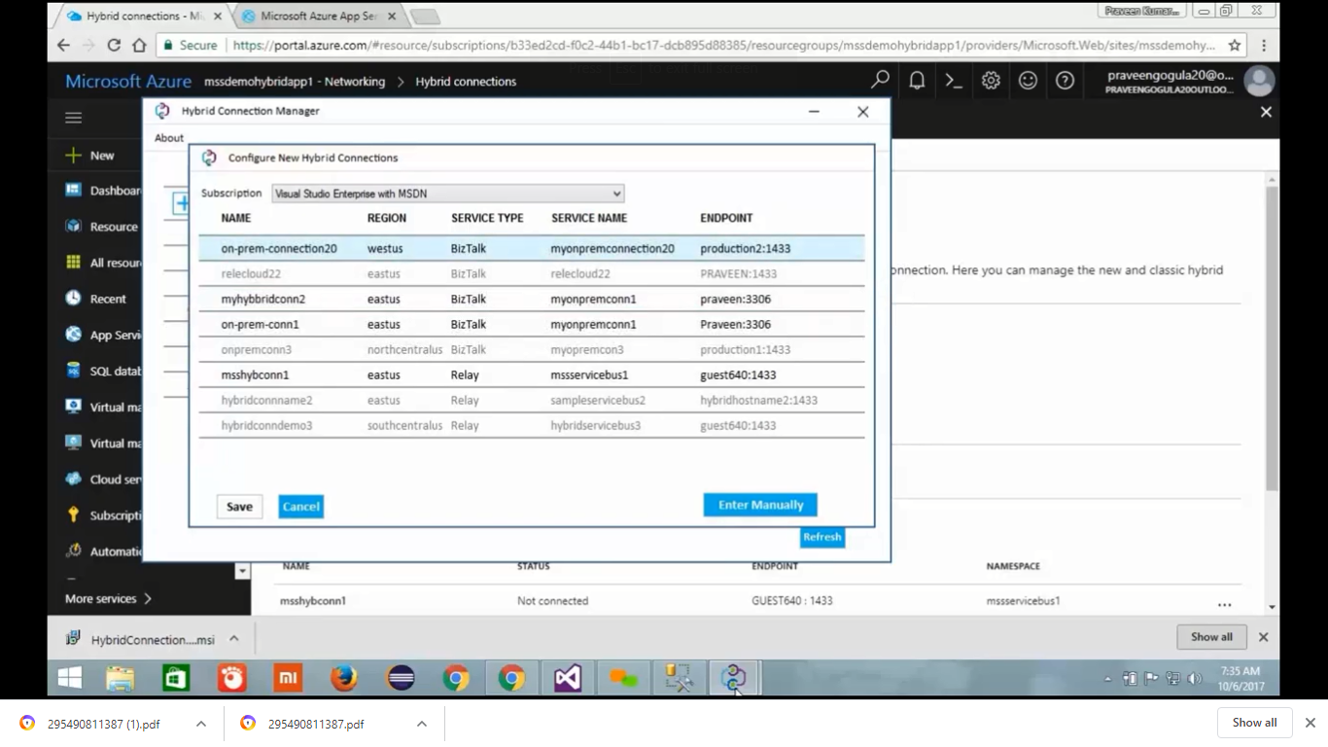

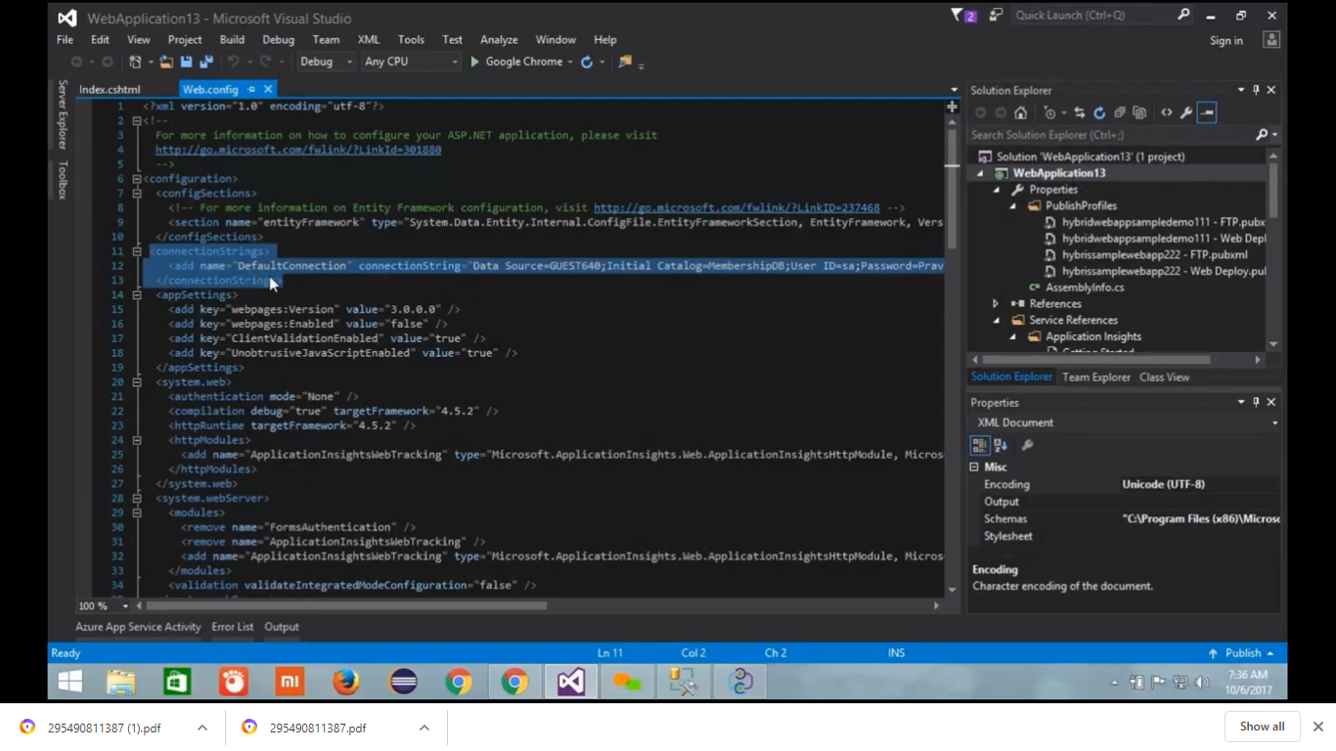

Download “Get publish profie”

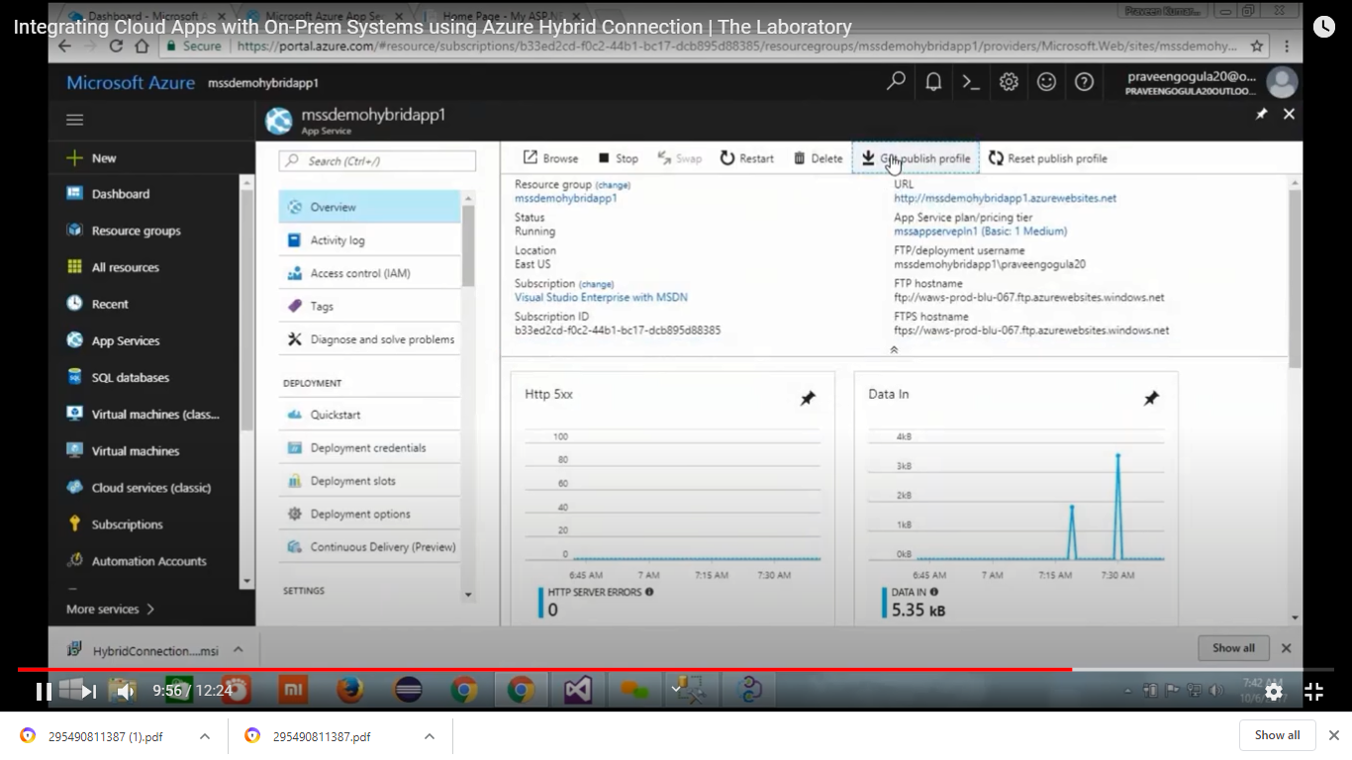

Update the connection string in application settings

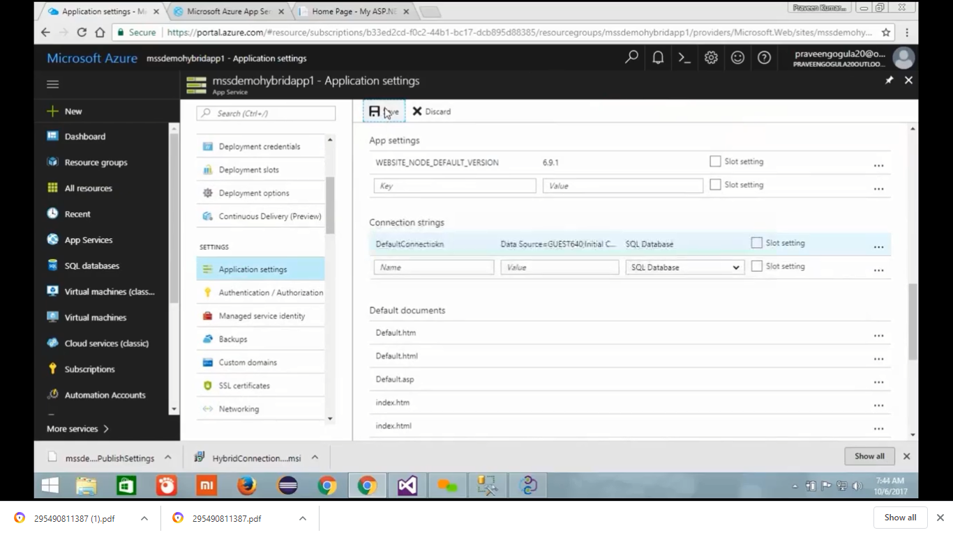

## Tools

* **Migration Assistant tool** helps you to examine your IIS installation. It helps you to recognize which site can be migrated to the cloud. It is also featuring components which are either not migrated or unsupported on the Azure platform.
* **Azure AD connect** tool help us to migrate AD from on premises to clould.

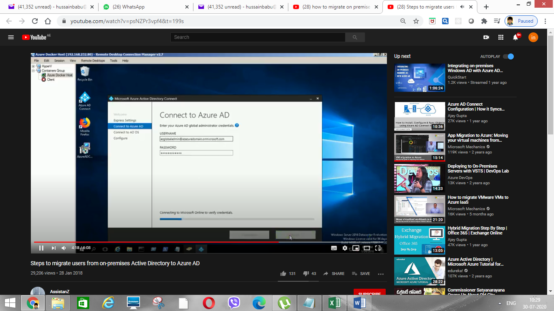

## Service principal

* **Service principal** in Active directory: This is another name for IAM/RBAC

## Availability set vs Availability zone:

* + Availability set contains Fault domain & Update domain.

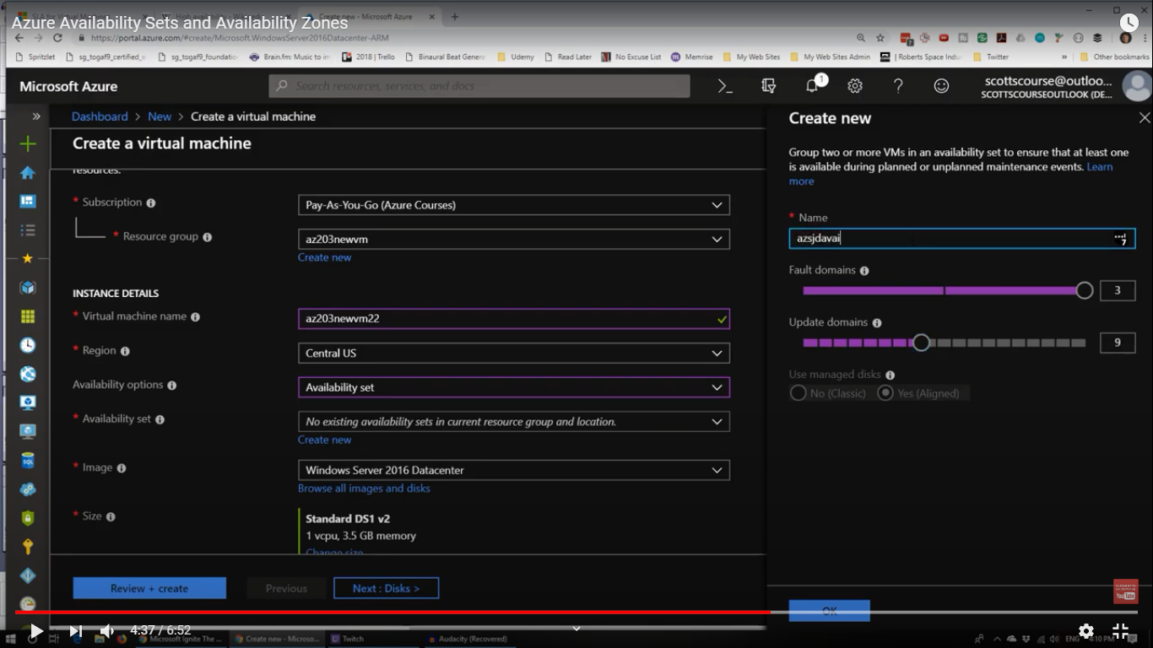

Availability zone:

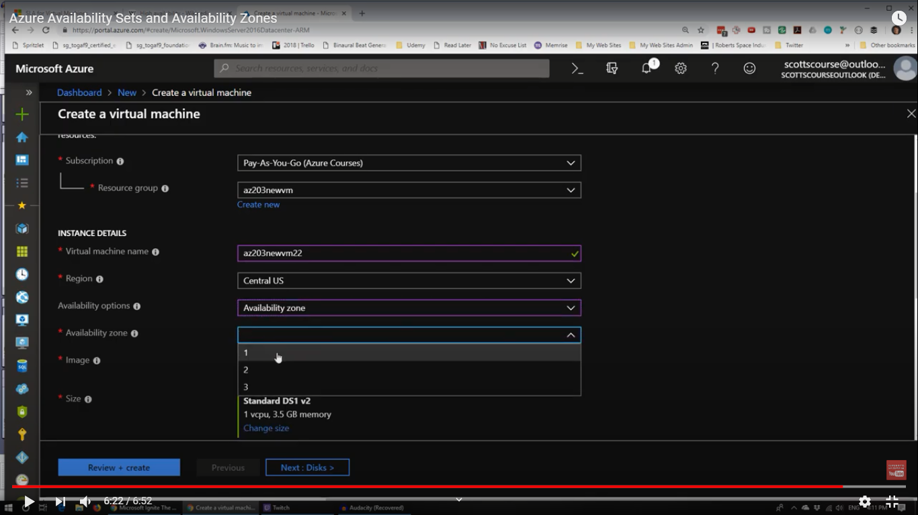

## Creating multiple resources with ARM template:

<https://www.youtube.com/watch?v=vGtApxuvYeE>

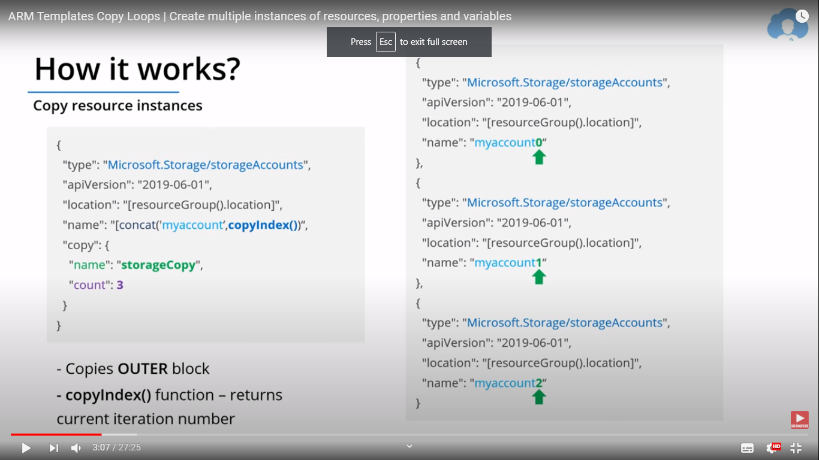

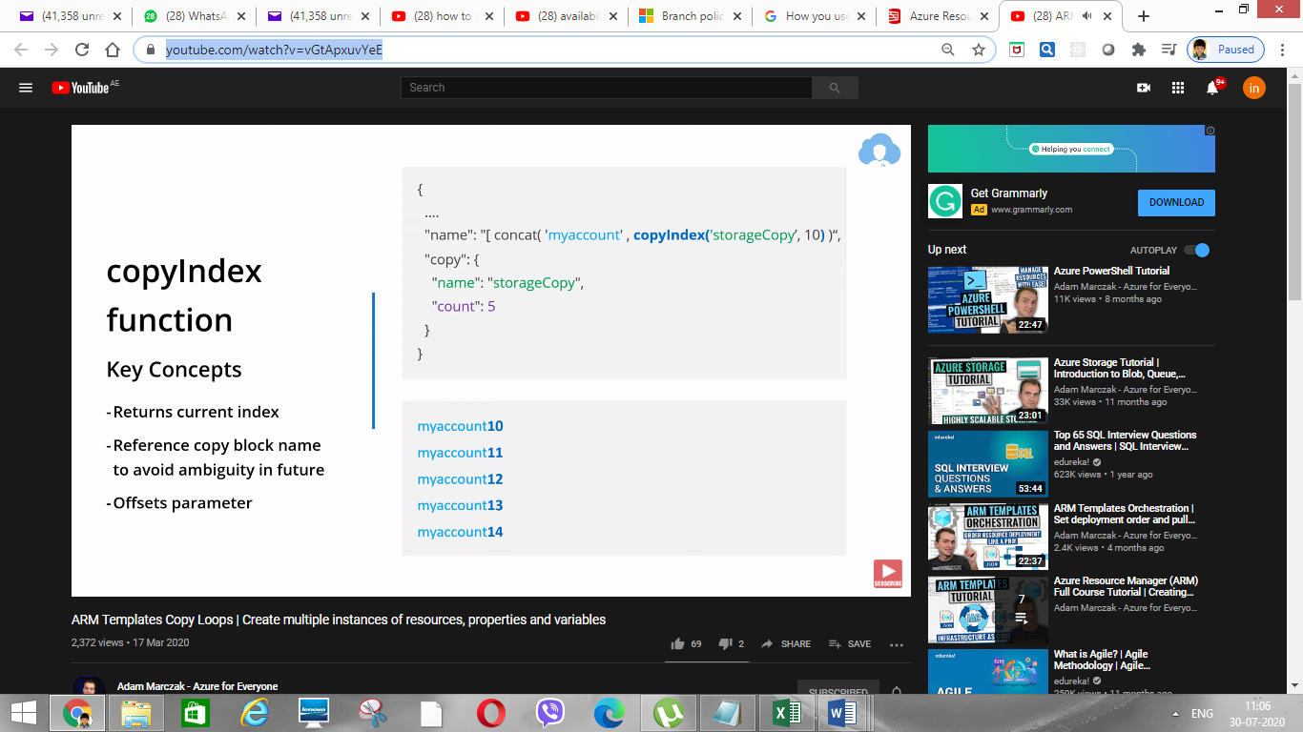

Parameterize template to create multiple resoucres

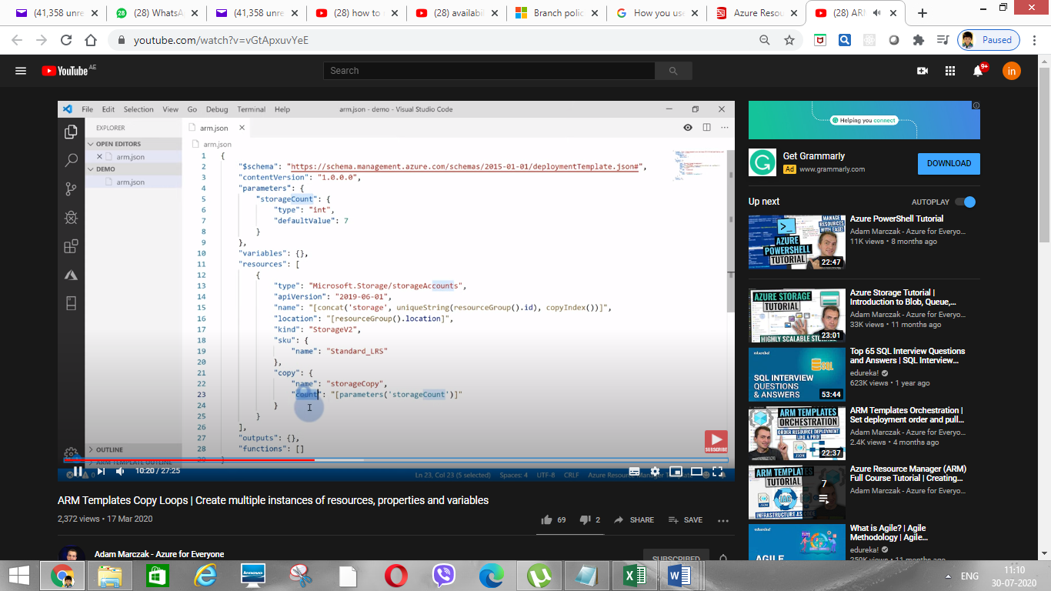

* Service fabrics:

**Azure Service Fabric is a distributed systems platform that makes it easy to package, deploy, and manage scalable and reliable microservices and containers.** Service Fabric also addresses the significant challenges in developing and managing cloud native applications. Developers and administrators can avoid complex infrastructure problems and focus on implementing mission-critical, demanding workloads that are scalable, reliable, and manageable. Service Fabric represents the next-generation platform for building and managing these enterprise-class, tier-1, cloud-scale applications running in containers.

## Connect & create VM with power shell

* Connect & create VM with power shell:

Connect:

**Connect-AzAccount**

Create VM:

* + seFirstly, create resource group: **New-AzResourceGroup.**
  + Secondly, create VM: **New-AzVM**

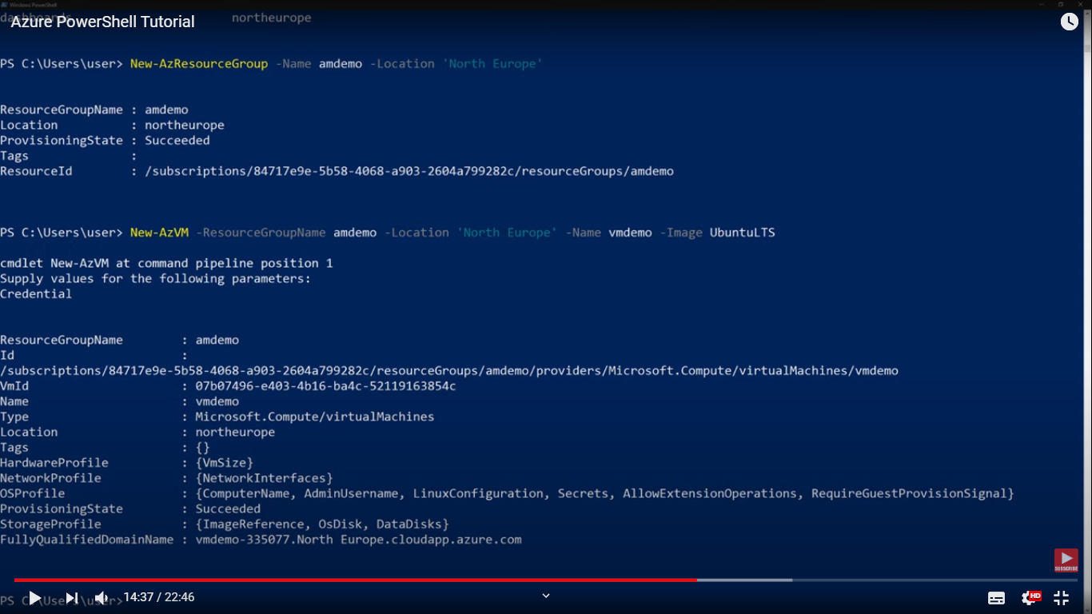

Creating 10 storage accounts:

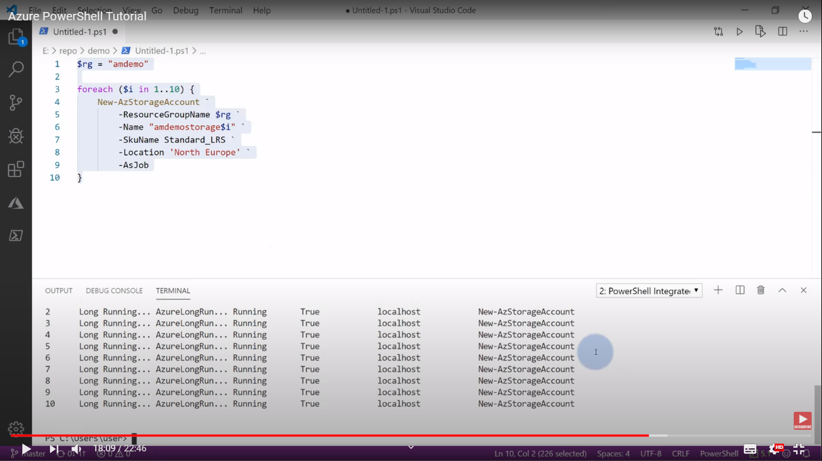

## Load balancer-scaleset availability set

* Scale set vs availableity set and load balancer

<https://www.youtube.com/watch?v=T7XU6Lz8lJw>

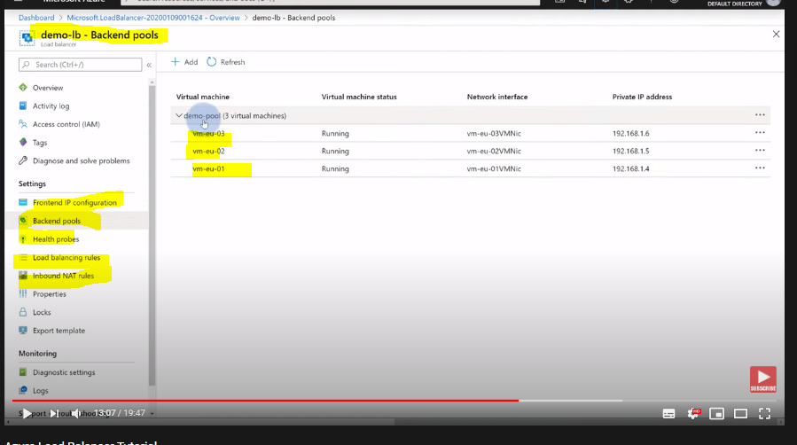

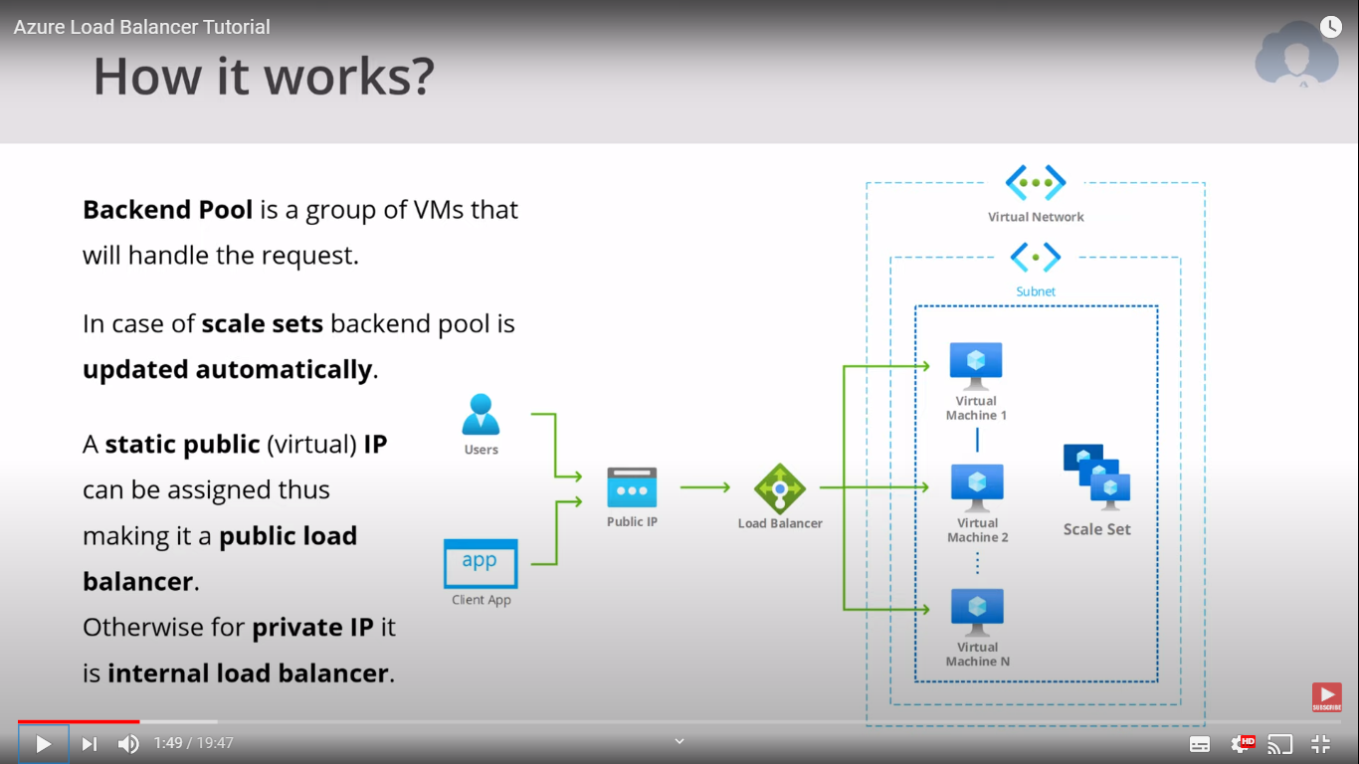

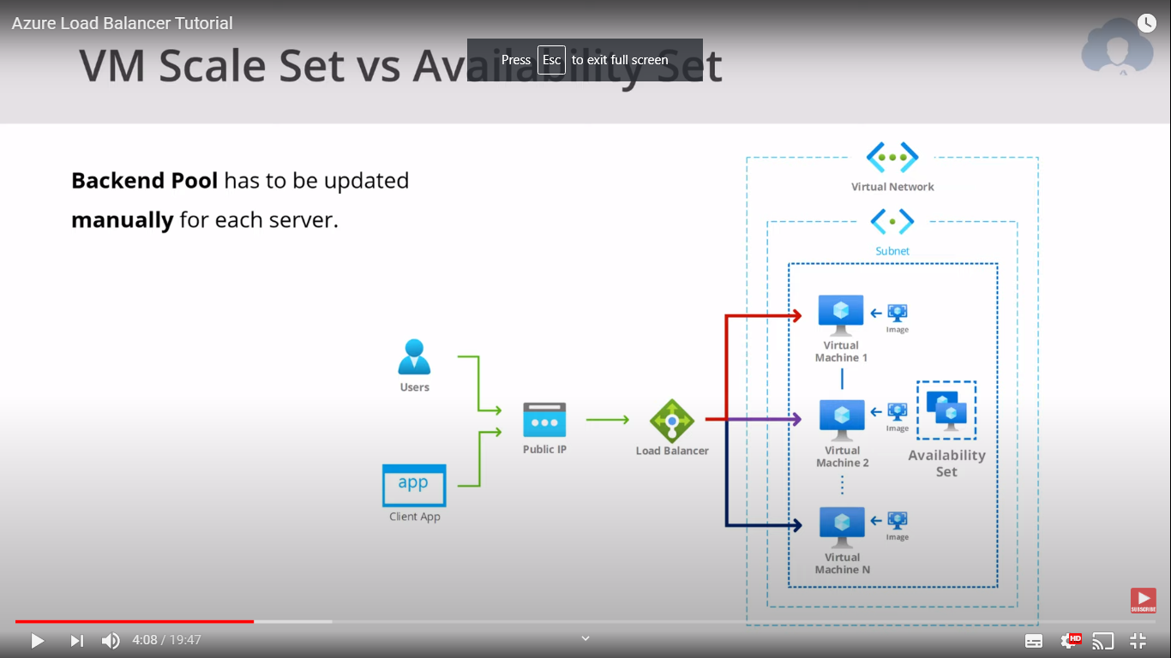

## Open Source Solutions

<https://span.eu/en/2017/05/discover-open-source-on-microsoft-azure/#:~:text=Microsoft%20lets%20its%20customers%20run,as%20Linux%2C%20Bitnami%20or%20Joomla.>

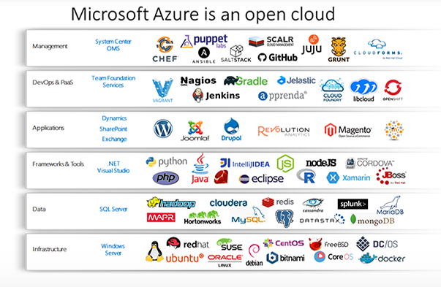

## Hybrid Identity

<https://www.youtube.com/watch?v=SS-5qDgPvJU>

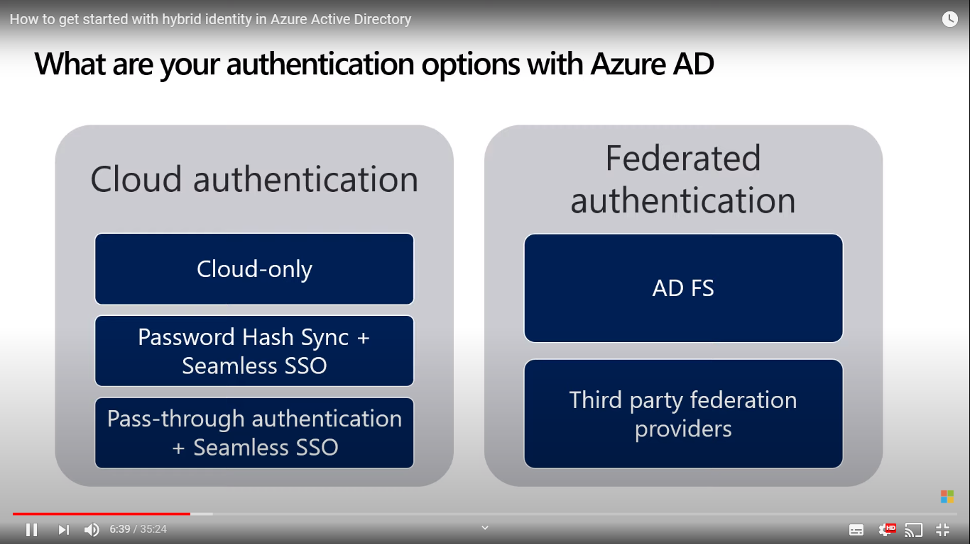

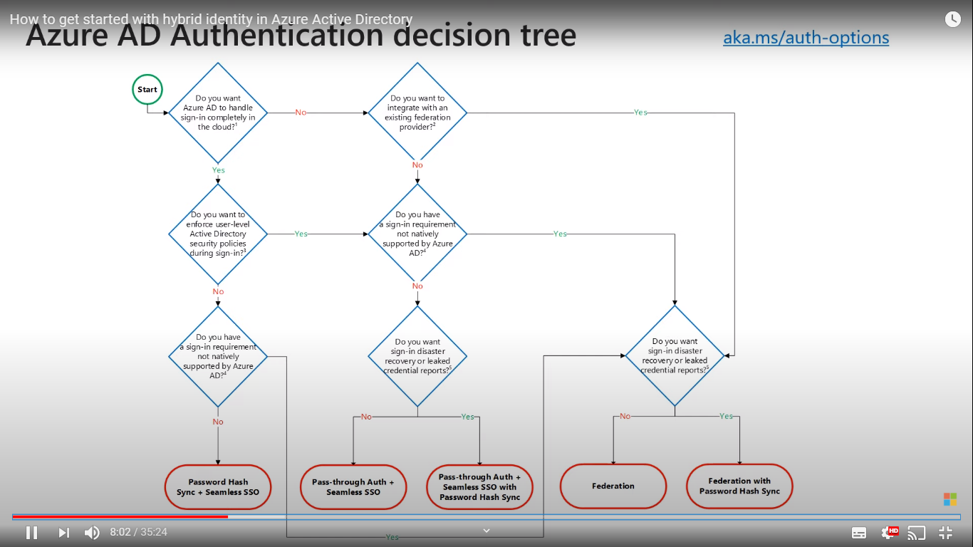

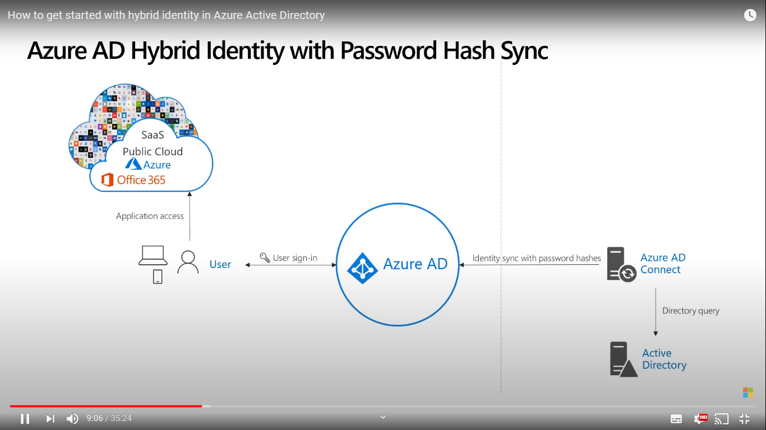

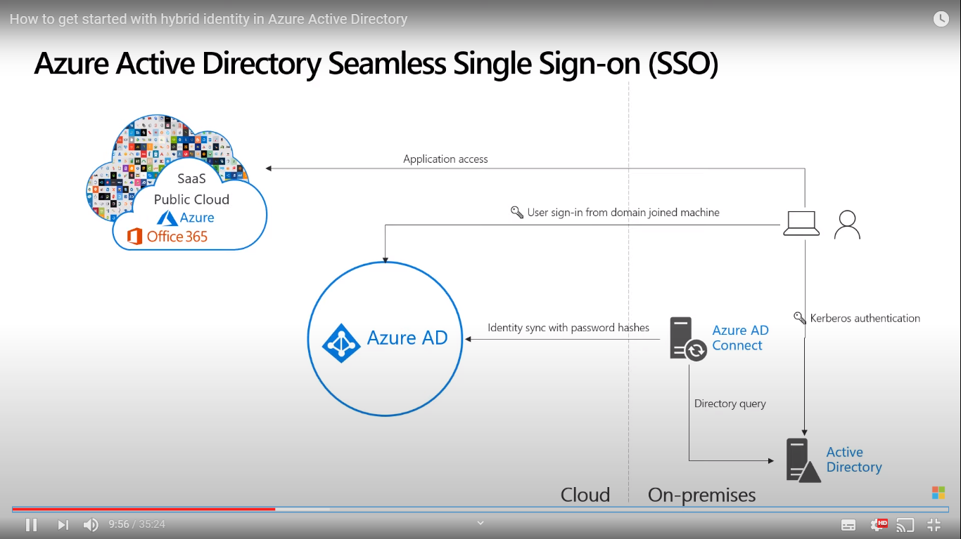

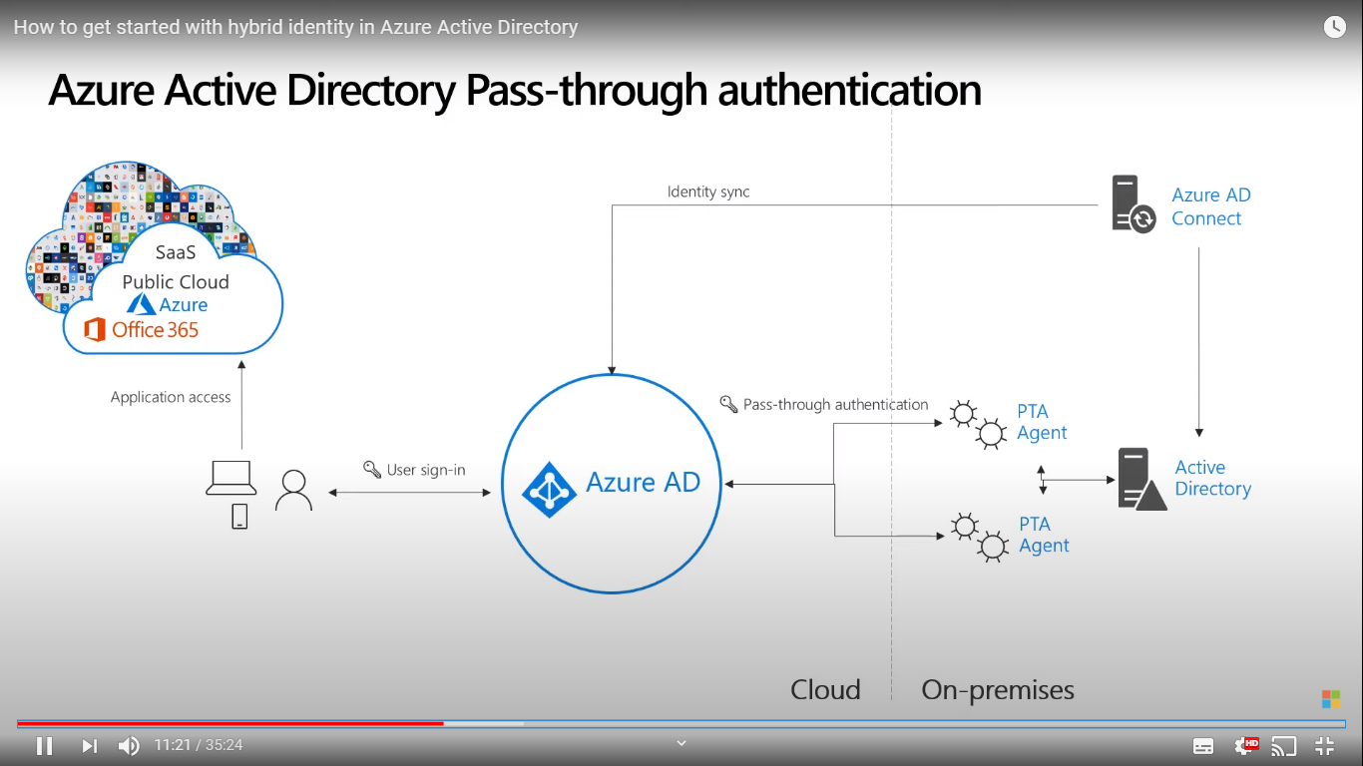

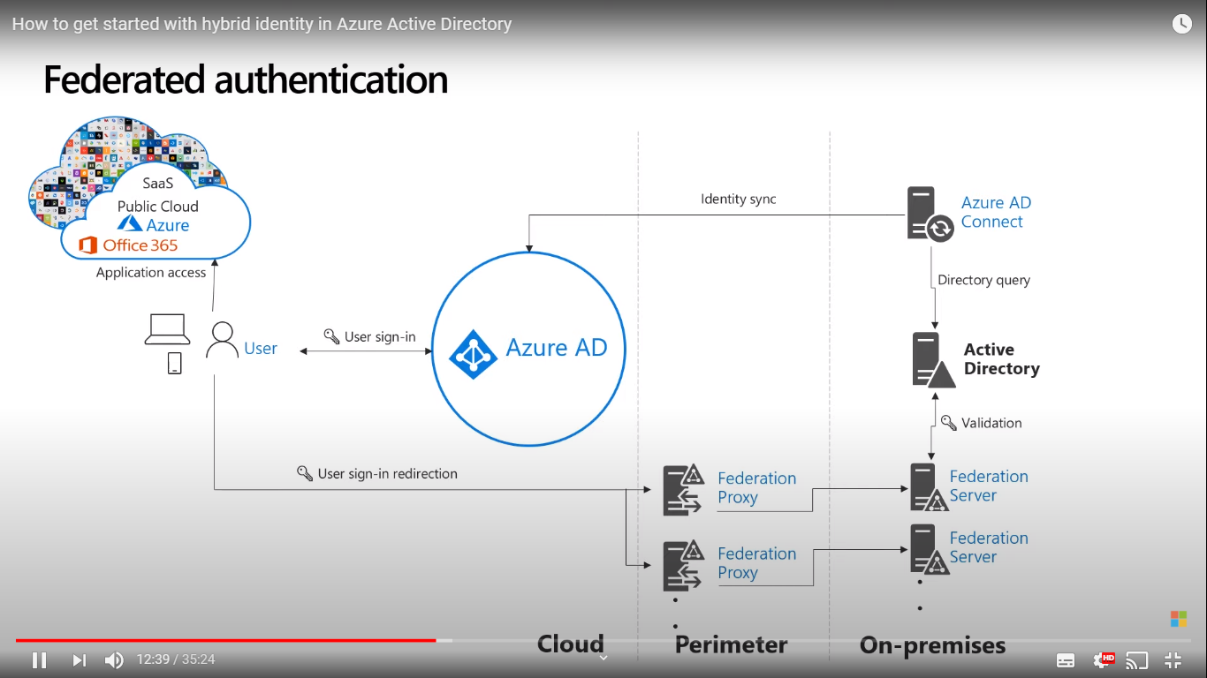

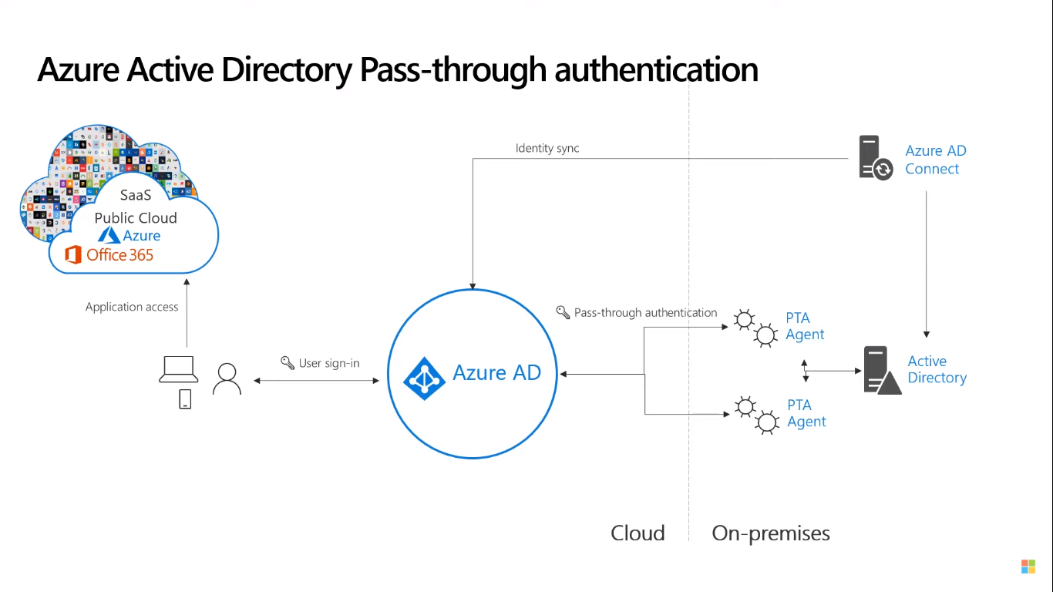

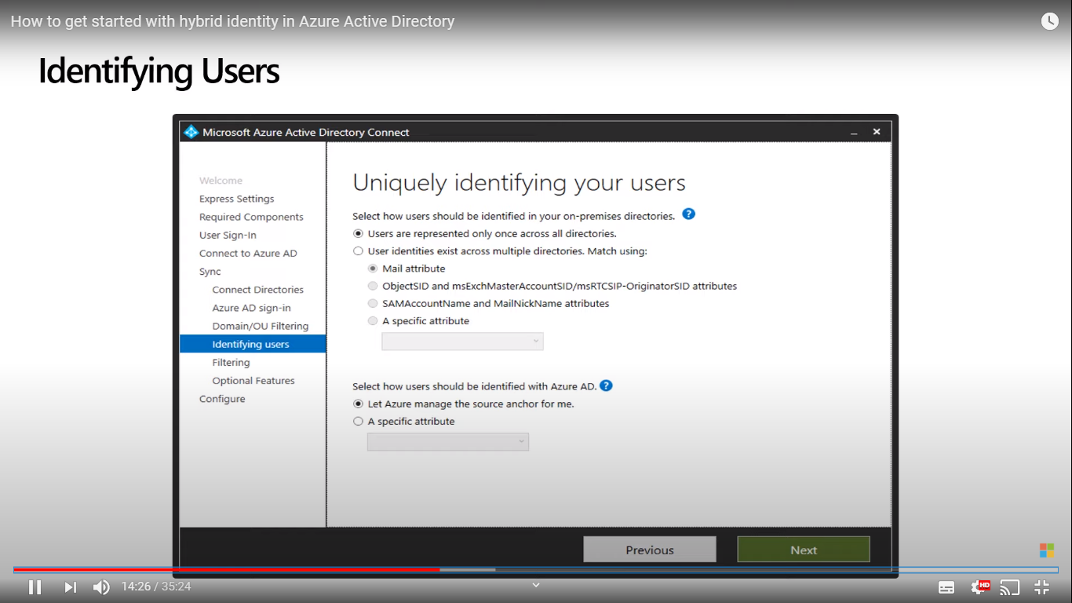

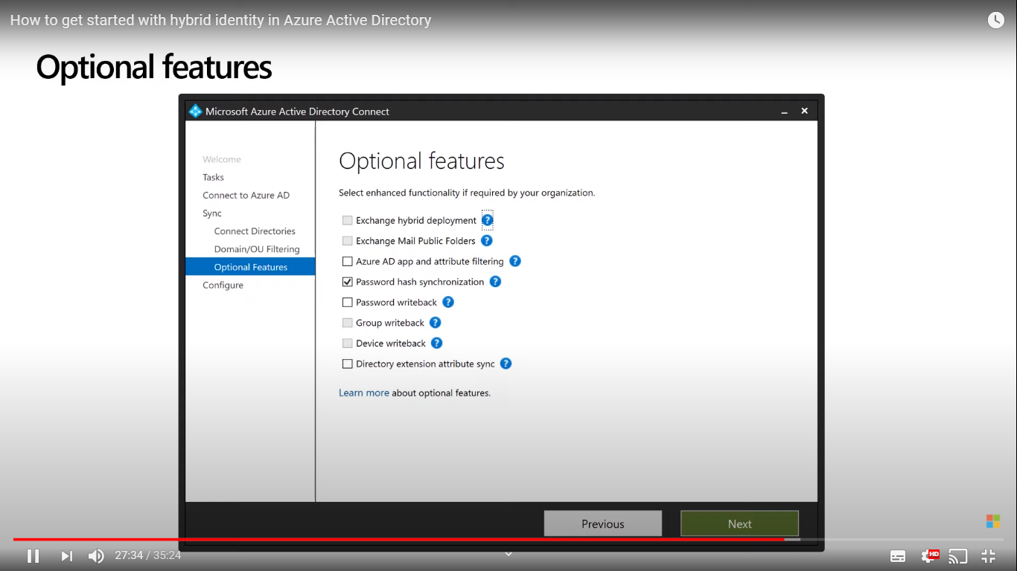

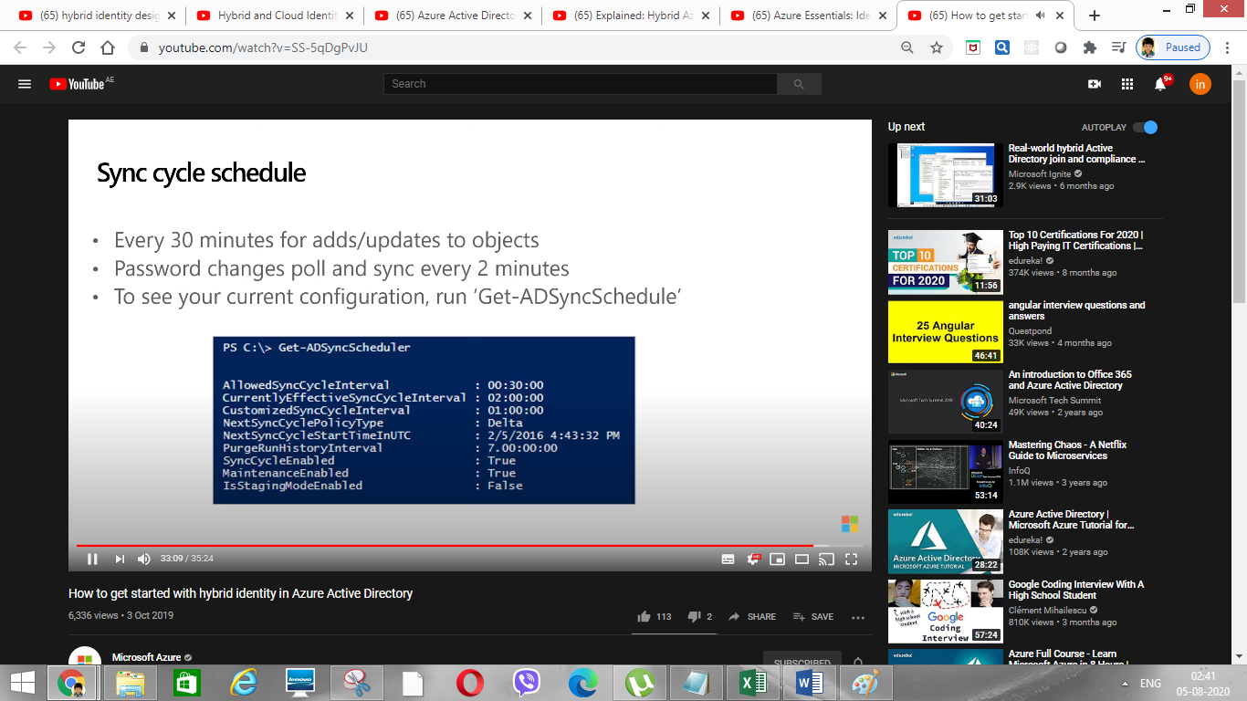

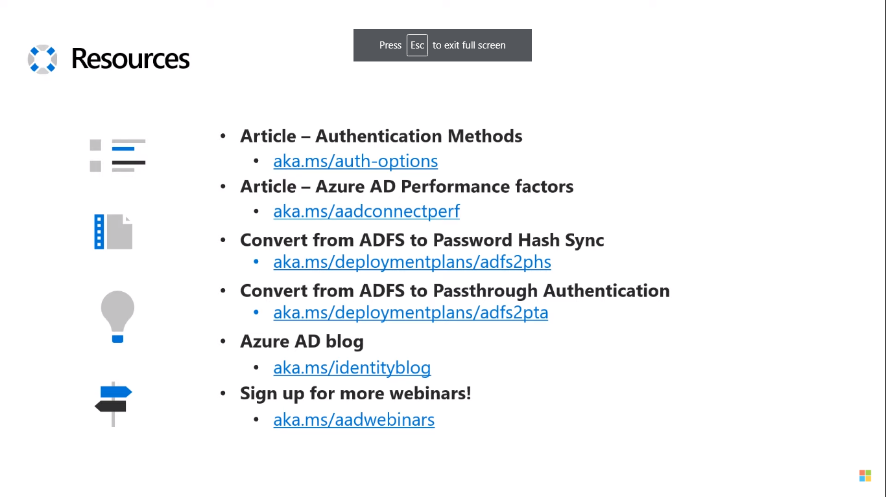

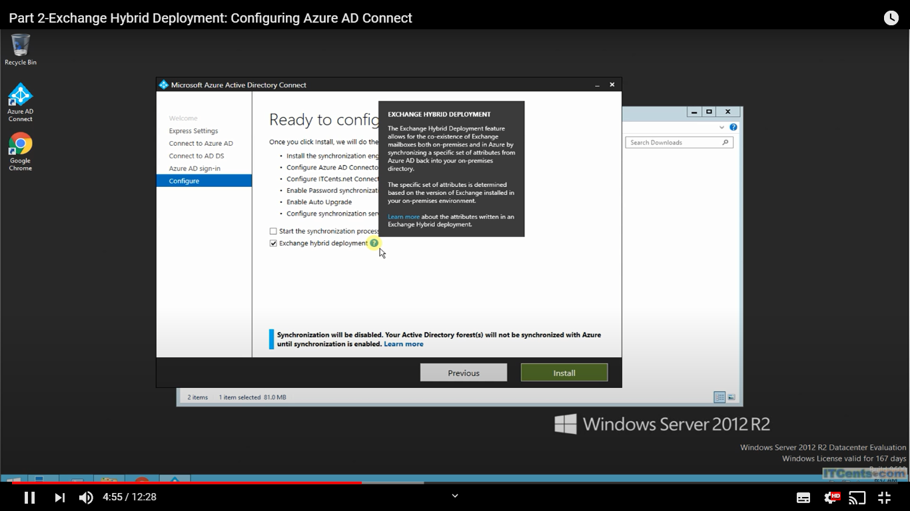

It helps to select the corp users

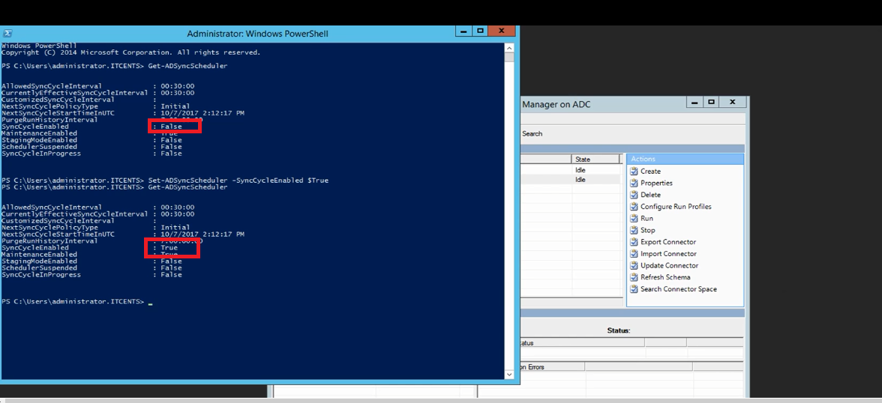

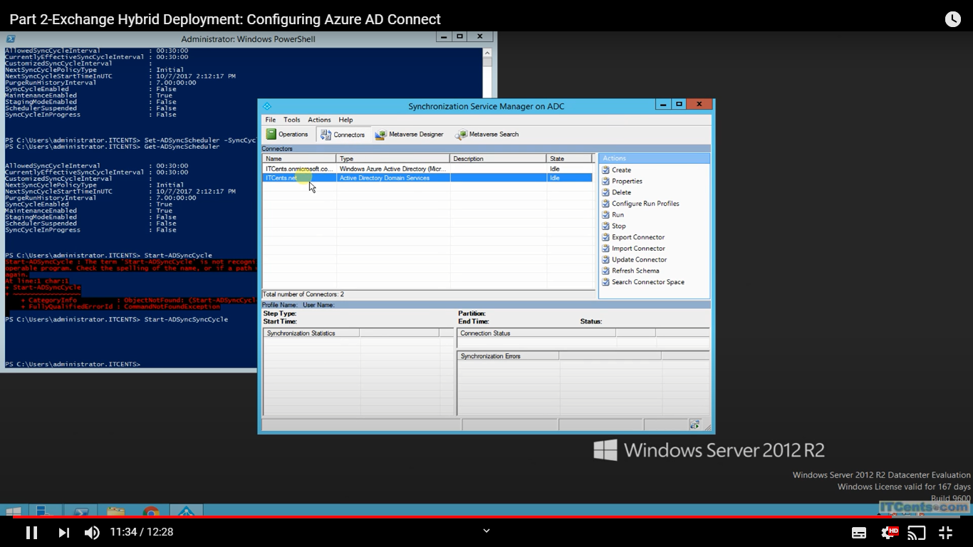

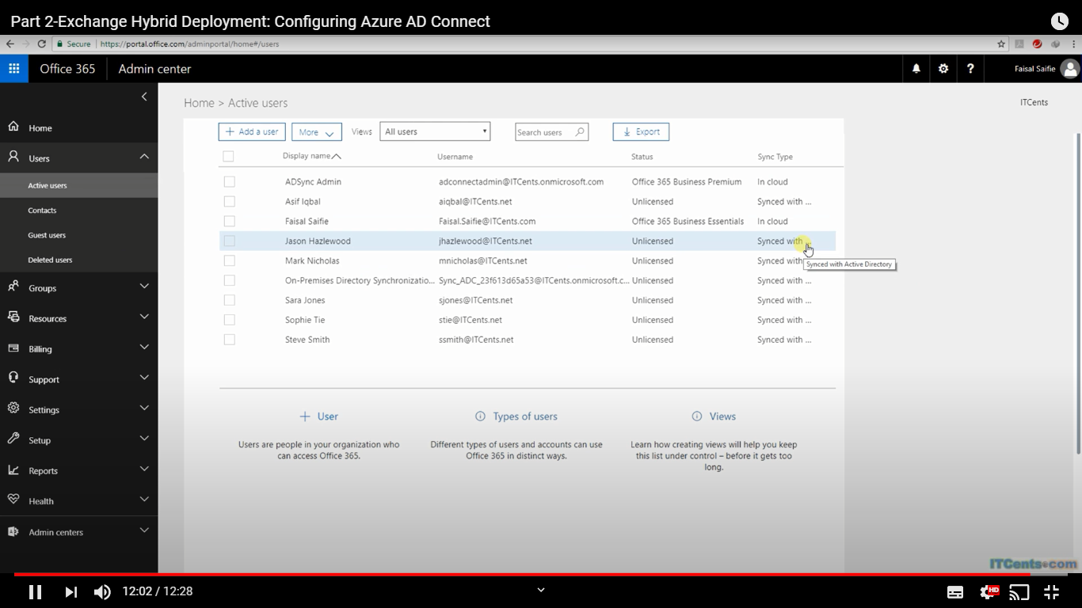

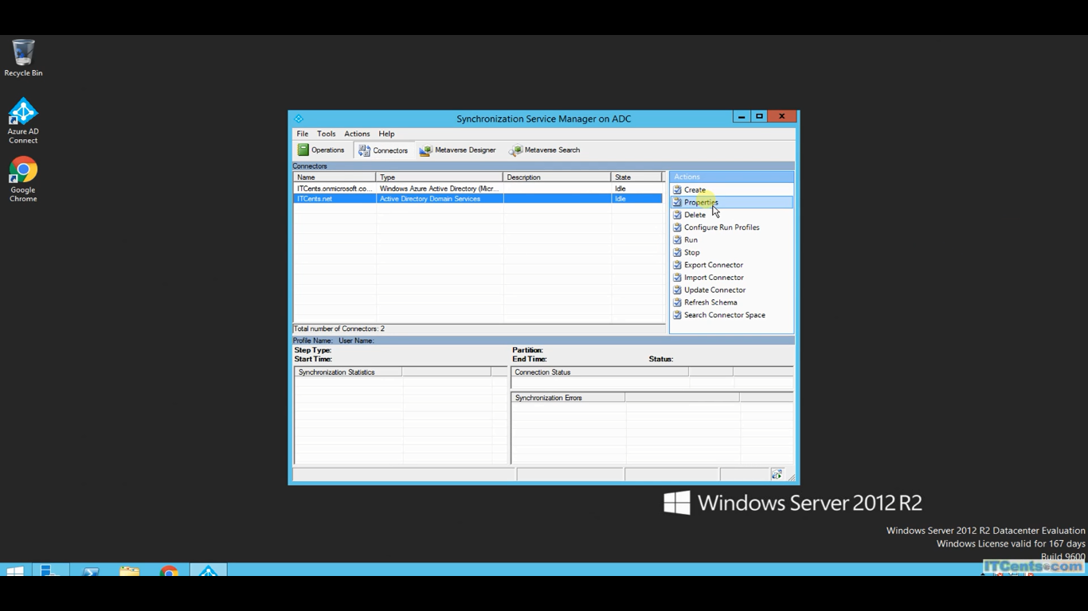

.

## Azure Security

<https://www.youtube.com/watch?v=urvrXoKWuFY>

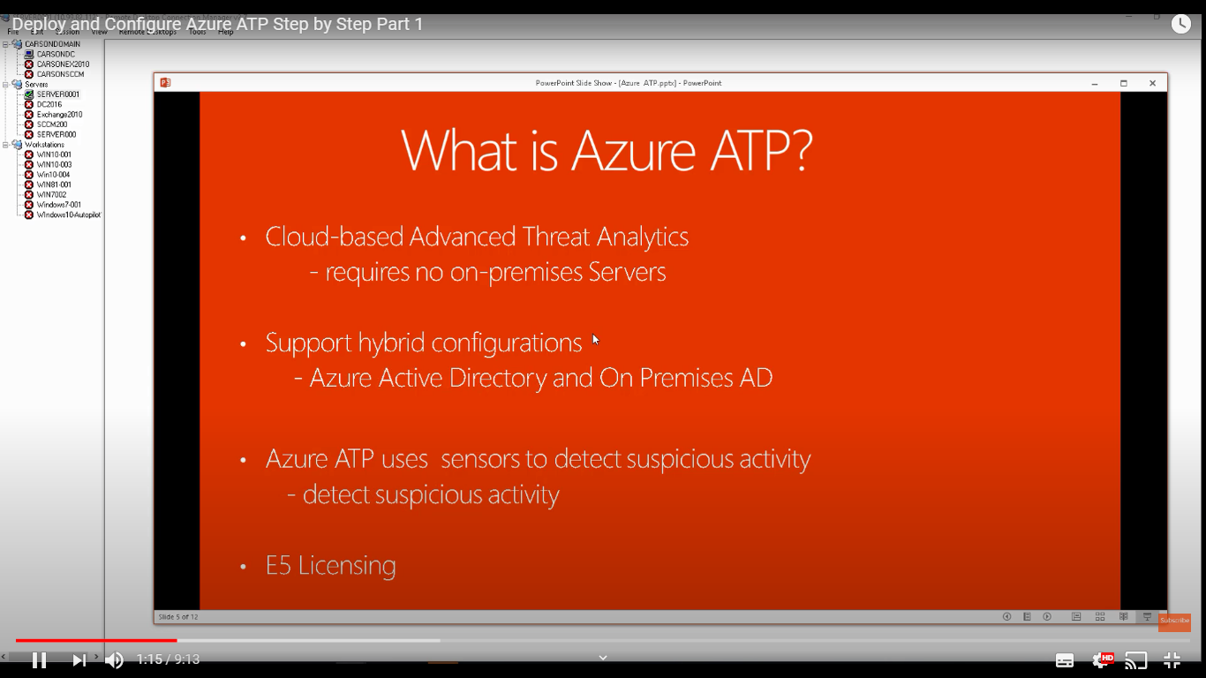

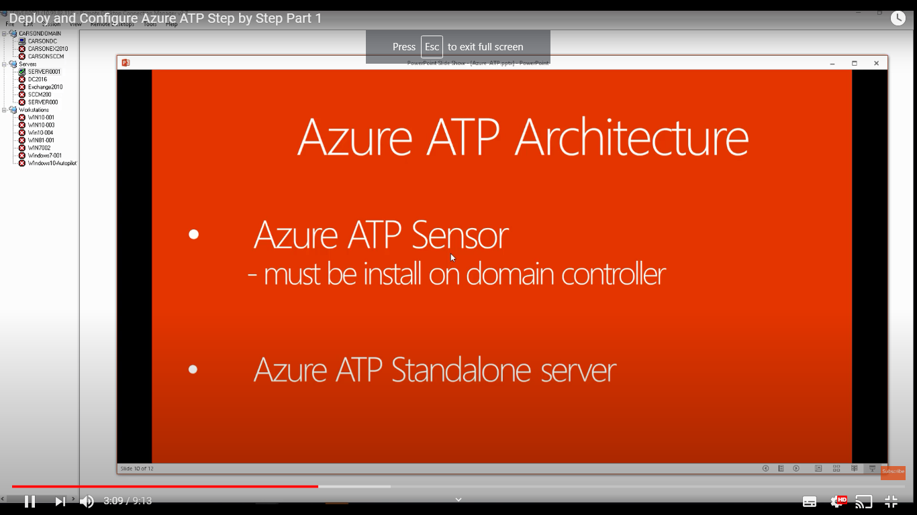

## Azure Dvelop

## 

## ers:

